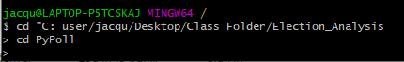cdGit Bash Nomenclature

jacqu@LAPTOP-P5TCSKAJ MINGW64 /c/users/jacqu/Desktop/Class Folder/Election_Analysis (master)



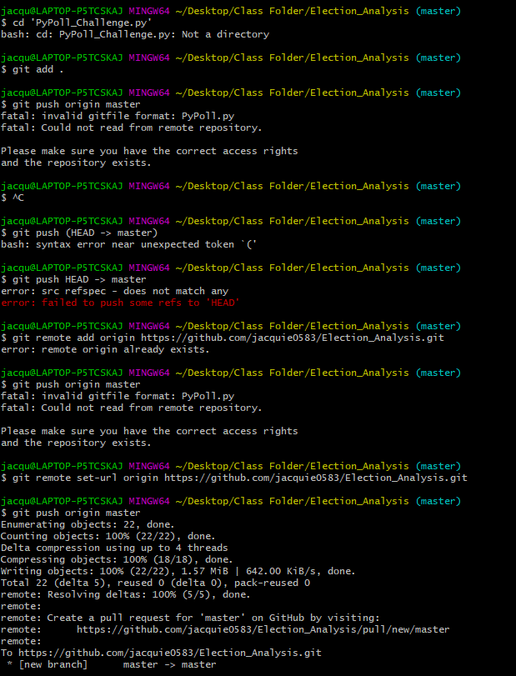

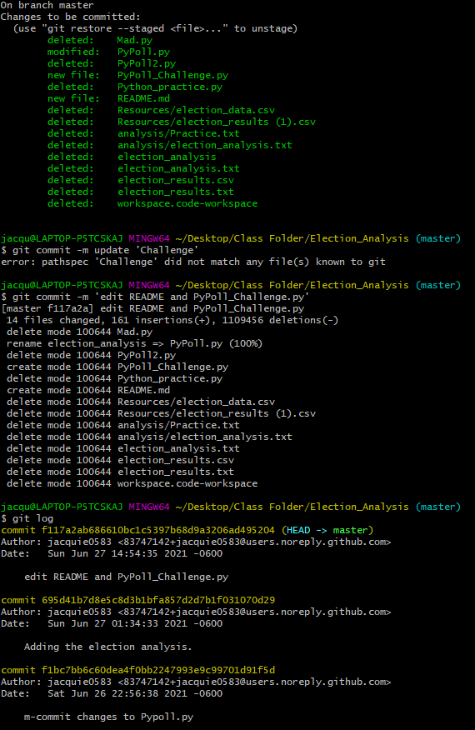

jacqu@LAPTOP-P5TCSKAJ MINGW64 ~/Desktop

$ cd 'Class Folder'

jacqu@LAPTOP-P5TCSKAJ MINGW64 ~/Desktop/Class Folder

$ cd 'Election_Analysis'

jacqu@LAPTOP-P5TCSKAJ MINGW64 ~/Desktop/Class Folder/Election_Analysis (master)

$ ls -a

./ ../ .git/ PyPoll_Challenge.py README.md

jacqu@LAPTOP-P5TCSKAJ MINGW64 ~/Desktop/Class Folder/Election_Analysis (master)

$ git remote -v

PyPoll.py https://github.com/jacquie0583/Election_Analysis.git (fetch)

PyPoll.py https://github.com/jacquie0583/Election_Analysis.git (push)

origin PyPoll.py (fetch)

origin PyPoll.py (push)

jacqu@LAPTOP-P5TCSKAJ MINGW64 ~/Desktop/Class Folder/Election_Analysis (master)

$ touch PyPoll.py

jacqu@LAPTOP-P5TCSKAJ MINGW64 ~/Desktop/Class Folder/Election_Analysis (master)

$ ls

PyPoll.py PyPoll_Challenge.py README.md

jacqu@LAPTOP-P5TCSKAJ MINGW64 ~/Desktop/Class Folder/Election_Analysis (master)

$ git staus

git: 'staus' is not a git command. See 'git --help'.

The most similar command is

status

jacqu@LAPTOP-P5TCSKAJ MINGW64 ~/Desktop/Class Folder/Election_Analysis (master)

$ git status

On branch master

Changes not staged for commit:

(use "git add/rm <file>..." to update what will be committed)

(use "git restore <file>..." to discard changes in working directory)

deleted: Mad.py

modified: PyPoll.py

deleted: PyPoll2.py

deleted: Python_practice.py

deleted: Resources/election_data.csv

deleted: Resources/election_results (1).csv

deleted: analysis/Practice.txt

deleted: analysis/election_analysis.txt

deleted: election_analysis

deleted: election_analysis.txt

deleted: election_results.csv

deleted: election_results.txt

deleted: workspace.code-workspace

Untracked files:

(use "git add <file>..." to include in what will be committed)

PyPoll_Challenge.py

README.md

no changes added to commit (use "git add" and/or "git commit -a")

jacqu@LAPTOP-P5TCSKAJ MINGW64 ~/Desktop/Class Folder/Election_Analysis (master)

$ git add .

jacqu@LAPTOP-P5TCSKAJ MINGW64 ~/Desktop/Class Folder/Election_Analysis (master)

$ git status

On branch master

Changes to be committed:

(use "git restore --staged <file>..." to unstage)

deleted: Mad.py

modified: PyPoll.py

deleted: PyPoll2.py

new file: PyPoll_Challenge.py

deleted: Python_practice.py

new file: README.md

deleted: Resources/election_data.csv

deleted: Resources/election_results (1).csv

deleted: analysis/Practice.txt

deleted: analysis/election_analysis.txt

deleted: election_analysis

deleted: election_analysis.txt

deleted: election_results.csv

deleted: election_results.txt

deleted: workspace.code-workspace

jacqu@LAPTOP-P5TCSKAJ MINGW64 ~/Desktop/Class Folder/Election_Analysis (master)

$ git commit -m update 'Challenge'

error: pathspec 'Challenge' did not match any file(s) known to git

jacqu@LAPTOP-P5TCSKAJ MINGW64 ~/Desktop/Class Folder/Election_Analysis (master)

$ git commit -m 'edit README and PyPoll_Challenge.py'

[master f117a2a] edit README and PyPoll_Challenge.py

14 files changed, 161 insertions(+), 1109456 deletions(-)

delete mode 100644 Mad.py

rename election_analysis => PyPoll.py (100%)

delete mode 100644 PyPoll2.py

create mode 100644 PyPoll_Challenge.py

delete mode 100644 Python_practice.py

create mode 100644 README.md

delete mode 100644 Resources/election_data.csv

delete mode 100644 Resources/election_results (1).csv

delete mode 100644 analysis/Practice.txt

delete mode 100644 analysis/election_analysis.txt

delete mode 100644 election_analysis.txt

delete mode 100644 election_results.csv

delete mode 100644 election_results.txt

delete mode 100644 workspace.code-workspace

jacqu@LAPTOP-P5TCSKAJ MINGW64 ~/Desktop/Class Folder/Election_Analysis (master)

$ git log

commit f117a2ab686610bc1c5397b68d9a3206ad495204 (HEAD -> master)

Author: jacquie0583 <83747142+jacquie0583@users.noreply.github.com>

Date: Sun Jun 27 14:54:35 2021 -0600

edit README and PyPoll_Challenge.py

commit 695d41b7d8e5c8d3b1bfa857d2d7b1f031070d29

Author: jacquie0583 <83747142+jacquie0583@users.noreply.github.com>

Date: Sun Jun 27 01:34:33 2021 -0600

Adding the election analysis.

commit f1bc7bb6c60dea4f0bb2247993e9c99701d91f5d

Author: jacquie0583 <83747142+jacquie0583@users.noreply.github.com>

Date: Sat Jun 26 22:56:38 2021 -0600

m-commit changes to Pypoll.py

jacqu@LAPTOP-P5TCSKAJ MINGW64 ~/Desktop/Class Folder/Election_Analysis (master)

$ git push origin master

fatal: invalid gitfile format: PyPoll.py

fatal: Could not read from remote repository.

Please make sure you have the correct access rights

and the repository exists.

jacqu@LAPTOP-P5TCSKAJ MINGW64 ~/Desktop/Class Folder/Election_Analysis (master)

$ git push <remote-repo> <local-branch>:<remote-branch>

bash: syntax error near unexpected token `<'

jacqu@LAPTOP-P5TCSKAJ MINGW64 ~/Desktop/Class Folder/Election_Analysis (master)

$ jacquie0583

bash: jacquie0583: command not found

jacqu@LAPTOP-P5TCSKAJ MINGW64 ~/Desktop/Class Folder/Election_Analysis (master)

$ /

bash: /: Is a directory

jacqu@LAPTOP-P5TCSKAJ MINGW64 ~/Desktop/Class Folder/Election_Analysis (master)

$ Election_Analysis

bash: Election_Analysis: command not found

jacqu@LAPTOP-P5TCSKAJ MINGW64 ~/Desktop/Class Folder/Election_Analysis (master)

$ git push 'Election_Analysis':'Election_Analysis'

ssh: Could not resolve hostname election_analysis: Name or service not known

fatal: Could not read from remote repository.

Please make sure you have the correct access rights

and the repository exists.

jacqu@LAPTOP-P5TCSKAJ MINGW64 ~/Desktop/Class Folder/Election_Analysis (master)

$ git push 'Election_Analysis':'Election_Analysis'

ssh: Could not resolve hostname election_analysis: Name or service not known

fatal: Could not read from remote repository.

Please make sure you have the correct access rights

and the repository exists.

jacqu@LAPTOP-P5TCSKAJ MINGW64 ~/Desktop/Class Folder/Election_Analysis (master)

$ git push -u origin master

fatal: invalid gitfile format: PyPoll.py

fatal: Could not read from remote repository.

Please make sure you have the correct access rights

and the repository exists.

jacqu@LAPTOP-P5TCSKAJ MINGW64 ~/Desktop/Class Folder/Election_Analysis (master)

$ git push PyPoll_Challenge

fatal: 'PyPoll_Challenge' does not appear to be a git repository

fatal: Could not read from remote repository.

Please make sure you have the correct access rights

and the repository exists.

jacqu@LAPTOP-P5TCSKAJ MINGW64 ~/Desktop/Class Folder/Election_Analysis (master)

$ git remote set-url PyPoll_Challenge https://github.com/jacquie0583/Election_Analysis.git

error: No such remote 'PyPoll_Challenge'

jacqu@LAPTOP-P5TCSKAJ MINGW64 ~/Desktop/Class Folder/Election_Analysis (master)

$ git remote set-url Election_Analysis https://github.com/jacquie0583/Election_Analysis.git

error: No such remote 'Election_Analysis'

jacqu@LAPTOP-P5TCSKAJ MINGW64 ~/Desktop/Class Folder/Election_Analysis (master)

$ cd PyPoll

bash: cd: PyPoll: No such file or directory

jacqu@LAPTOP-P5TCSKAJ MINGW64 ~/Desktop/Class Folder/Election_Analysis (master)

$ cd PyPoll.py

bash: cd: PyPoll.py: Not a directory

jacqu@LAPTOP-P5TCSKAJ MINGW64 ~/Desktop/Class Folder/Election_Analysis (master)

$

jacqu@LAPTOP-P5TCSKAJ MINGW64 ~/Desktop/Class Folder/Election_Analysis (master)

$ cd 'PyPoll.py'

bash: cd: PyPoll.py: Not a directory

jacqu@LAPTOP-P5TCSKAJ MINGW64 ~/Desktop/Class Folder/Election_Analysis (master)

$ ls

PyPoll.py PyPoll_Challenge.py README.md

jacqu@LAPTOP-P5TCSKAJ MINGW64 ~/Desktop/Class Folder/Election_Analysis (master)

$ cd PyPoll_Challenge.py

bash: cd: PyPoll_Challenge.py: Not a directory

jacqu@LAPTOP-P5TCSKAJ MINGW64 ~/Desktop/Class Folder/Election_Analysis (master)

$ cd 'PyPoll_Challenge.py'

bash: cd: PyPoll_Challenge.py: Not a directory

jacqu@LAPTOP-P5TCSKAJ MINGW64 ~/Desktop/Class Folder/Election_Analysis (master)

$ git add .

jacqu@LAPTOP-P5TCSKAJ MINGW64 ~/Desktop/Class Folder/Election_Analysis (master)

$ git push origin master

fatal: invalid gitfile format: PyPoll.py

fatal: Could not read from remote repository.

Please make sure you have the correct access rights

and the repository exists.

jacqu@LAPTOP-P5TCSKAJ MINGW64 ~/Desktop/Class Folder/Election_Analysis (master)

$ ^C

jacqu@LAPTOP-P5TCSKAJ MINGW64 ~/Desktop/Class Folder/Election_Analysis (master)

$ git push (HEAD -> master)

bash: syntax error near unexpected token `('

jacqu@LAPTOP-P5TCSKAJ MINGW64 ~/Desktop/Class Folder/Election_Analysis (master)

$ git push HEAD -> master

error: src refspec - does not match any

error: failed to push some refs to 'HEAD'

jacqu@LAPTOP-P5TCSKAJ MINGW64 ~/Desktop/Class Folder/Election_Analysis (master)

$ git remote add origin https://github.com/jacquie0583/Election_Analysis.git

error: remote origin already exists.

jacqu@LAPTOP-P5TCSKAJ MINGW64 ~/Desktop/Class Folder/Election_Analysis (master)

$ git push origin master

fatal: invalid gitfile format: PyPoll.py

fatal: Could not read from remote repository.

Please make sure you have the correct access rights

and the repository exists.

jacqu@LAPTOP-P5TCSKAJ MINGW64 ~/Desktop/Class Folder/Election_Analysis (master)

$ git remote set-url origin https://github.com/jacquie0583/Election_Analysis.git

jacqu@LAPTOP-P5TCSKAJ MINGW64 ~/Desktop/Class Folder/Election_Analysis (master)

$ git push origin master

Enumerating objects: 22, done.

Counting objects: 100% (22/22), done.

Delta compression using up to 4 threads

Compressing objects: 100% (18/18), done.

Writing objects: 100% (22/22), 1.57 MiB | 642.00 KiB/s, done.

Total 22 (delta 5), reused 0 (delta 0), pack-reused 0

remote: Resolving deltas: 100% (5/5), done.

remote:

remote: Create a pull request for 'master' on GitHub by visiting:

remote: https://github.com/jacquie0583/Election_Analysis/pull/new/master

remote:

To https://github.com/jacquie0583/Election_Analysis.git

* [new branch] master -> master

jacqu@LAPTOP-P5TCSKAJ MINGW64 ~/Desktop/Class Folder/Election_Analysis (master)

$

